GNANAMANI COLLEGE OF TECHNOLOGY

Department: BIO MEDICAL ENGINEERING

Year: III rd. YEAR

TOPIC: SMART WATER MANAGEMENT

Team members

1.Gowri Sankar. S

2.Kaushik. E

3.Jegan. S

4.Hari Krishnan. k

5.Gowtham. V

# INTRODUCTION:

The average annual rainfall in Maharashtra is around 6000 mm. The rainfall pattern is not distributed equally over all regions in India. The rainwater storage facility is not proper so that the water can be utilized for drinking purpose. On the other hand, the use of water is also improper. Many people, organization and Industries are working for developing the awareness about saving the water. Indian government is also spreading awareness with Save the Water initiative. Still the efforts made need to be improved in order to fulfil the need of water for growing population of India.

IoT in water management is opening the opportunities for proper utilization of water resources. The tap water available needs to be checked for the quality. Maintaining the quality of water is a challenge, on the other hand preserving the water and minimizing the use of water is another area need to be addressed.

This paper presents an IOT device which help to manage and plan the uses of water the system can easily monitor and installed for long purpose the current scenario of water management system is the MNC supplies water to commercial homes, apartments Industries after 3 to 4 days so people try to store water for daily needs for next few days but in that case we don’t know how much water consume or usage by Homes or apartments. This project can easily work in urban as well as Ural areas with the help of IOT based Water management system we can easily calculate the water consumption and helps to pay proper taxes.

In this system instead of providing water after 3or 4 days we will supply on the daily basis continually from MNC and we are also going to set water limit how much water is use if he exceeds the limit water will trip by MNC and it will open to next day. The purpose we are using IOT system is that now a days people get directly bill or tax note in the form of paper so it’s very time-consuming process. In this system peoples get SMS regarding billing and taxes directly on mobile instantly so that they don’t need to wait for bills the Data will continually monitor amount of water analyze by user. Water is basic need of human being, and it needs to be preserved. India is facing the problems with the uneven distribution of monsoon over different regions country.

# MOTIVATION OF RESEARCH:

The water being the one of the basic needs of all human being needs to be preserved for future generations. The system for monitoring the quality and supply of water is one of the most important needed systems. The billing of water is uniform for all in India. It is necessary to revise the billing system for the water on the factors such as, amount of water used, the season in which the water is used, and the reason for which the water is used. In order to reduce the waste of water, it is mandatory to study the water utilization pattern of the population. The proposed system will provide the water to tap on 24/7 basis. The proposed billing for the water is prepaid. The rates of water supplied can be varied according to the availability of water. It avoids unnecessary unhygienic storage of water at households as the water will be made available 24/7.

# OBJECTIVES OF RESEARCH:

The focus of the proposed system is to-

* Control the per liter utilization of water.
* Monitoring the water supplied through tap.
* Providing 24/7 water to tap
* Saving the water through proper distribution system
* Increasing the revenue of water billing through prepaid system
* Analysis of water utilization data and revision of the billing

BLOCK DIAGRAM OF PROPOSED SYSTEM

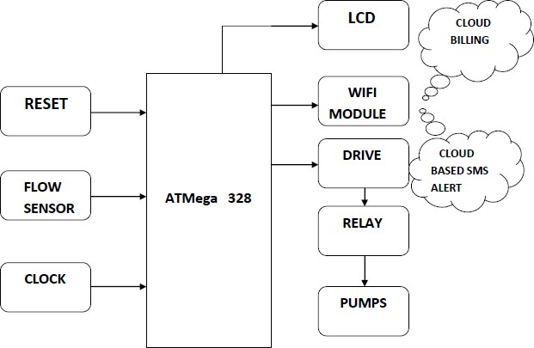

Fig.1: Block Diagram of IOT based Water Management System

In this IOT based water management system water uses monitor and control by using sensor and Microcontrollers where the sensor will monitor the use of water if it exceeds its limit then it will cut off the water supply from municipal corporation so the charges need to pay for the water used by user no fixed water tax is needed to pay also, we can check water usage as data sent on cloud server. This will help to know about the amount of water used and how much use has more to use.

# PROPOSED METHODOLOGY:

The Arduino based system for management of water is proposed to be developed by Authors. Authors have proposed to use flow sensor, microcontroller, pump, and the relays. The objective of the work is to develop the low-cost solution for water management in India.

SYSTEM REQUIREMENT:

|  |  |  |
| --- | --- | --- |
| **Sr.**  **No.** | **Components** | **Specifications** |
| 1 | AT mega 328 | 8Bit, 54 digital Input/ Output pins, 16 analogs  inputs, 4 UART |
| 2 | Pump | 5A, 230V, DC Motor |
| 3 | Relays | 5A, 230V |
| 4 | Wi-Fi Module | ESP8266 |
| 5 | GSM Module | RS-232, 900/1800 MHz |
| 6 | LCD | 16*2 LCD Display |
| 7 | Flow Sensor | E8FC-25D |

**CONCLUSION:**

The proposed system can provide the data of water utilization of each consumer on daily basis. The supply of water can also be controlled according to the number of people present in the family. The main problems associated with the water supply are uncontrolled supply and uncontrolled use. The IoT based system controls the amount of water supplied to each consumer. Instead of fixed water tax, one can pay the charges as per utilization of water. The system may also be useful in spreading the awareness of proper utilization of water. Authorities can define the rate of water according to utilization pattern and people may use the water.